5. Compliance@Production Facilities

Compliance is also relevant in the manufacturing area. Therefore, it is important to identify and to know how to handle possible Compliance topics in that part of the business.

|  |
| --- |
| Identified fields of Compliance related challenges are:  Handling of Company property  Theft of equipment constitutes damage to the company`s property and must be reported (see [„[IncidentReporting@Siemens“](https://intranet.for.siemens.com/cms/056/en/processes/security/Pages/incident-reporting.aspx) (IR@S) or [GM SEC Abteilung](https://intranet.for.siemens.com/cms/056/de/processes/security/Pages/incident-reporting.aspx))](https://compliance.siemens.cloud/bcg/procedures.html)    Scrap and leftover material from the production must be handled in a proper way (see [One pager](https://findit.compliance.siemens.com/content/10000101/Compliance/LC_CO/LC_CO_STR/findIT_LC_CO_STR_5132.pdf))  Handling of Company information requires considerable vigilance  Your signature your responsibility means that those who have authority to sign should always check very carefully what they are about to approve when they are asked to sign (see [Integrity Moments 201](javascript:Download('https://findit.compliance.siemens.com/content/10000101/Compliance/CL_CO/CL_CO_AT/findIT_CL_CO_AT_6495.pptx'))8)  Conflict of interest [(see Chapter A.4.)](https://webbooks.siemens.com/public/LC/chen/index.htm?n=Part-1-Activity-Fields,A.-Anti-Corruption,4.-Conflict-of-interest)  Reporting of wrongdoing (see [Business Conduct Guidelines, Chapter “Our reporting procedures”).](https://compliance.siemens.cloud/bcg/procedures.html)  Child labor is strictly prohibited at production facilities ([see Chapter E.6.6.1.1.)](https://webbooks.siemens.com/public/LC/chen/index.htm?n=Part-1-Activity-Fields,E.-Human-Rights,6.-Toolbox,6.6.-Risk-factors/areas,6.6.1.-Labor-Issues-and-OHS,6.6.1.1.-Child-labor). |

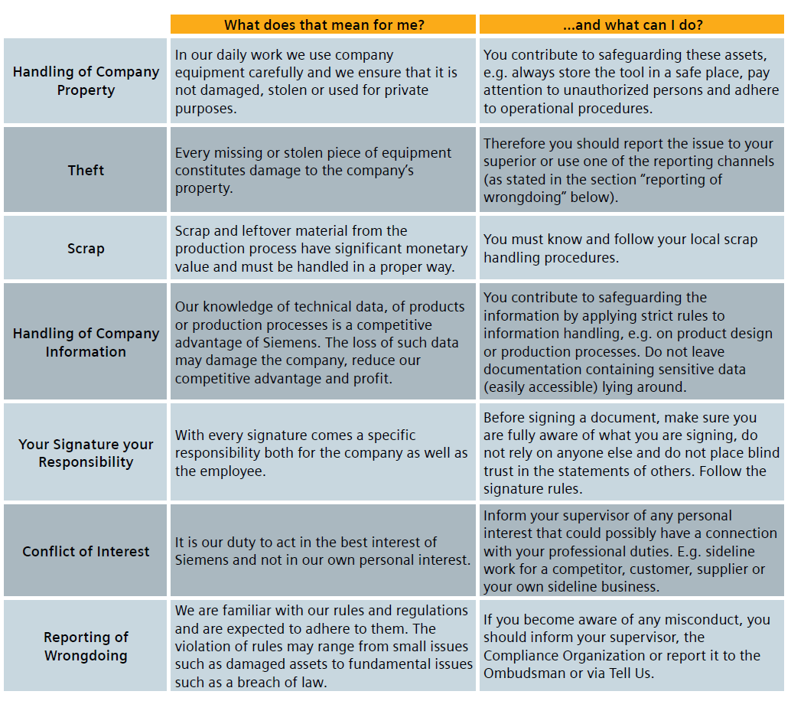

## 5.1. Training and supporting documents

The **Quick guide**: Compliance@Production Facilities can be found here.

[English version](https://findit.compliance.siemens.com/content/10000101/Compliance/LC_CO/LC_CO_EM/findIT_LC_CO_EM_5501.pdf)

[German version](https://findit.compliance.siemens.com/content/10000101/Compliance/CL_CO/CL_CO_AT/findIT_CL_CO_AT_5629.pdf)

[NL version](https://findit.compliance.siemens.com/content/10000101/Compliance/CL_CO/CL_CO_AT/findIT_CL_CO_AT_5630.PDF)

A **scribble video** explaining SIEMENS Compliance at production facilities can be found [here](https://myvideo.siemens.com/media/SIEMENS+Compliance+Factory+EN+Subtitle/1_pdob8fjt) (available also in Dutch). It explains in a smart and easy to understand way how Compliance also has an effect within production facilities. The Video uses a potential theft as an example to explain:

* Compliance in general
* tasks of the compliance organization
* actions in case of theft
* reporting channels
* whistleblowing
* Compliance and ownership culture.

A **special WBT** for colleagues in production facilities will be available soon.

One pager: How to tackle scrap-related issues can be found [here](https://findit.compliance.siemens.com/content/10000101/Compliance/LC_CO/LC_CO_STR/findIT_LC_CO_STR_5132.pdf).

[**Protection Concept Factory**](https://wiki.siemens.com/display/en/Protection+Concept+Factory#space-menu-link-content) for critical IT assets also exists.

## 5.2. History of changes

|  |  |  |
| --- | --- | --- |
| **Date** | **Author** | **Major changes of binding content** |
| April 1, 2020 | Yvonne Hamm-Düppe | Initial version |
| July 1, 2020 | Yvonne Hamm-Düppe  Tanja Gerecke | Minor editorial changes |
| Oct. 1, 2020 | Yvonne Hamm-Düppe  Tanja Gerecke | Minor editiorial changes |

## 5.3. Contacts

Compliance Officer

The Compliance Officer responsible for your unit can be found through the following [link](https://intranet.for.siemens.com/cms/059/en/about/org/Pages/compliance_organization.aspx).

Corporate Governance Owner

[Tanja Gerecke](https://scd.siemens.com/luz/IdentitySearch?suchart=schnell&maxanz=50&cn=gerecke%2C%20tanja&cngenau=contains&lang=de) (LC CO DI MC)

[Yvonne Hamm-Düppe](https://scd.siemens.com/luz/IdentitySearch?cn=hamm-dueppe&suchart=schnell&utI=I&utX=X&utT=T&rtH=H&rtS=S&rtZ=Z&rtO=O&rtAktiv=A) (LC CO RFC LF)